W06 Team Activity Designer
Cameron Briggs

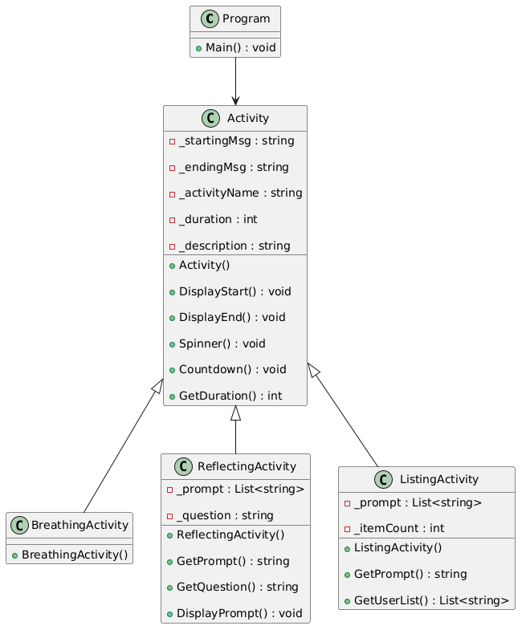

- A menu allow user to choose an activity.
- The 3 activity classes inherit from the base Activity class
- Common starting message with activity name and description
- Prompt user for duration in seconds, tells user to prepare and pauses
- End with common ending message, display activity name and time, pauses

